## Supplementary Materials

**Results: Reaction time by contingency phase**

A study by Prinzmetal et al. (2009) demonstrated that both voluntary and involuntary attention impact reaction times. Voluntary (exogenous) and involuntary (automatic or endogenous) attention were assessed in a spatial cueing task developed by Posner and colleagues (Posner, 1980). Voluntary attention was evaluated in trials with informative or predictive cues (80% valid trials) whereas involuntary attention was assessed using uninformative cues (25% of valid trials, for four possible target locations). The authors found that both voluntary and involuntary attention shorten RT (lack of attention, therefore, increases RT), and voluntary attention additionally affects accuracy. Follow up studies have further validated this effect of attention on RT.

In our study, RT was not affected by the anxiety manipulation, which argues against “classical” attention being the main driving factor of the altered learning effects. Similarly, a previous study explicitly assessed the relation between attention and anxiety and showed that state anxiety was not linked to slower reaction times (Bishop, 2009).

We additionally assessed RT separately in blocks of unpredictable cues (50-50 contingency phase) and highly predictable cues (90-10 contingency phase) and assessed how they were affected by anxiety. We averaged the RT across all 50-50 contingency trials and separately 90-10 trials and performed a pair-wise permutation test comparing the mean RT between StA and Cont groups separately for each contingency category. The results demonstrate that in the 90-10 contingency phase there is no significant difference between StA (M = 667, SEM = 34) and Cont (M = 641, SEM = 49, P = 0.76). Likewise, there was no difference in the 50-50 contingency phase between the StA group (M = 683, SEM = 40) and Cont group (M = 684, SEM = 58, P = 0.98).

**Efficiency of β coefficients in the GLM model**

Collinearity of regressors was an issue in our initial GLM design, as abs(epsi2) and epsi3 were highly correlated. A common practice is to orthogonalise collinear regressors in the model to solve the problem of reduced power and unreliable parameter estimates in the GLM (Mumford et al., 2018). However, other authors argue that despite the potential appeal of orthogonalisation of regressors to remove collinearity from the model, the implications are actually not necessarily beneficial: it does not improve the overall fit of the model, and in most cases, it can lead to a misleading interpretation of the resulting inferences (Vanhove, 2020). We followed this second line of argument and chose to keep only one of the pwPE regressor trajectories instead. To inform our decision, we calculated the **efficiency for β coefficients** as proposed by Mumford et al. (2018) as a useful index to assess a priori our chosen explanatory variables (abs(e2) and e3):

The equation above is taken from Mumford et al. (2018) and is valid for a GLM with two regressors, x1 and x2, associated with two β coefficients β1 and β2. N is the number of observations (400 trials in our case).

We estimated the efficiency for β1 (regression coefficient for abs(e2)) and β2 (regression coefficient for e3) in each control and experimental group separately, and we obtained the following (mean and SEM across subjects):

**Control group:**

Efficiency for β1 (ε2): 47 (16)

Efficiency for β2 (ε3): 0.33 (0.03)

**StA group:**

Efficiency for β1 (ε2): 15.7 (6.9)

Efficiency for β2 (ε3): 0.57 (0.08)

Although the exact values of the efficiency indices are not informative, what this analysis reveals is that the efficiency for the β regression coefficient associated with abs(ε2) is much higher than for e3, due to larger variance in abs(ε2). Accordingly, we kept abs(ε2) in our GLM analysis and excluded regressor ε3. In addition, as indicated in the main manuscript, we used regressor outcome (win/lose trials), as it was expected to explain a large proportion of the variance in the EEG data.

A similar analysis of the efficiency of regression coefficients for the final GLM model using abs(ε2) (β1) and outcome (β2), demonstrated that efficiency for beta coefficients was in the same order of magnitude for both regressors:

**Control group:**

Efficiency for β1 (abs(ε2)): 94 (10)

Efficiency for β2 (outcome): 62 (2)

**StA group:**

Efficiency for β1 (abs(ε2)): 34 (12)

Efficiency for β2 (outcome): 63 (5)

Notably, while the efficiency for the β regression coefficient associated with the outcome regressor was very similar in both groups, the efficiency for β1 associated with abs(ε2) was considerably lower in the StA group, relative to control participants.

**Modulations of single-trial ERPs by trial outcome.**

Trial outcomes were represented by a large cluster of activity in both the Cont and StA group and with a similar latency. In the Cont group, trial outcomes significantly modulated EEG activity from 229 ms to 257 ms post stimulus over parietal-occipital and central-parietal electrodes, with a maximum effect at 242 ms in central parietal-occipital sites (*PFWE* < 0.0001). A second cluster of similar size occurred between 583 ms to 618 ms with a peak at 598 ms over left parietal and central electrodes (*PFWE* < 0.0001). Four further significant effects of a smaller cluster size were found earlier between 267-287 ms (*PFWE* = 0.002) and 642-654 ms (*PFWE* = 0.018) in right frontal and temporal electrodes, and between 567-583 ms (*PFWE* = 0.016) in right parietal electrodes, and in frontocentral electrodes between 408-424 ms (*PFWE* = 0.028, see **Supplementary Figure 9;** Details on the cluster effects can be found in **Table 2**).

In the StA group, trial outcomes significantly modulated trial-wise EEG responses from 228 ms to 316 ms across frontocentral regions, with a maximum effect at 277 ms in right frontal central electrodes (*PFWE* < 0.0001, **Supplementary Figure 9**). An additional smaller significant cluster was found between 286-297 ms in right parietal electrodes (*PFWE* = 0.04), and later between 558-569 ms (*PFWE* = 0.036) and 669-681 ms (*PFWE* = 0.042) in right parietal electrodes (cluster effects can be found in **Table 2**). There were no between-group differences in the representation of trial outcomesin EEG activity.

## Supplementary Figures

**Supplementary** **Figure 1. Scheme of the experimental task structure.** The experiment was split into four blocks: the first resting-state block (R1: baseline), task block 1 (TB1), task block 2 (TB2), and the final resting state block (R2). Both groups (StA and Cont) started with 5 minutes of resting state (R1) consisting of EEG and ECG recording. Prior to TB1, the StA group were informed of the experimental manipulation of public speaking about an unknown artwork in front of 3 experts, to be carried out after the computer learning task (TB1, TB2) had finished. This aimed to induce anxiety during TB1 and TB2 for the StA group, as indicated by hatched lines. The Cont group were told to expect to describe the same artwork to themselves for an identical period of time. Both groups undertook the reward-learning task across two blocks (TB1, TB2). After completing TB2, the StA group were informed they would not need to speak publicly about the artwork, and that they would, in an identical fashion to the Cont group, only need to present the artwork to themselves. When finished with this self-presentation, the final resting state block of ECG and EEG was recorded (R2).

**Supplementary Figure 2. HGF parameter estimation.** We simulated responses in an ideal observer, receiving the input from participant #1 in the control group. The responses were simulated using as model parameter values those listed in Table 1 (fixed parameters μ2(0) = 0, σ2(0) = 0.1, μ3(0) = 1, σ3(0) = 1, κ = 1) but we also set the values of ω2, ω3 and the response model parameter ζ. Different simulated responses were created by using different values of ω2 (-5.5 to -2.5 in steps of 0.5; 70 repetitions in each case), ω3 (-8.5 to -6.5, in steps of 0.5, 70 repetitions), ζ (4 to 8 in steps of 0.5; 70 repetitions). Next, we fitted the simulated responses and the input with the HGF winning model used for the empirical data and estimated the parameter values that best account for the simulated behavioural data. The prior values used for ω2 and ω3 were -4 and -7, respectively (variance 16 in both cases). Prior values are denoted by the diamond shape in the top panels. Panels A-C are boxplots (median, 25 and 75 percentiles) illustrating the results of parameter estimation for ω2 (A), ω3 (B) and ζ (C). The x-axis represents the set parameters introduced in the simulated responses (labelled “sim”), while y-axis data reveal the corresponding estimated value of that same parameter (labelled “fit”). Parameter recovery was excellent in the case of ω2 and ζ, as there was a high significant correlation between simulated and estimated (fit) values: Pearson R = 0.9497, *P* << 1 x 10-6 for ω2, R = 0.8167, *P* << 1 x 10-6 . Parameter ω3 could not be well recovered: R = 0.02, *P* = 0.5383.

**Supplementary Figure 3. HGF parameter estimation.** Same as **Supplementary Figure 2** but usingsimulated responses in an ideal observer receiving the input from participant #1 in the StA group. Parameter recovery was excellent for ω2 and ζ, as simulated and estimated (fit) values were highly significantly correlated: Pearson R = 0.9834, *P* = 0 for ω2, R = 0.8225, *P* << 1 x 10-6 . ω3 could not be well recovered: R = -0.0898, *P* = 0.047.

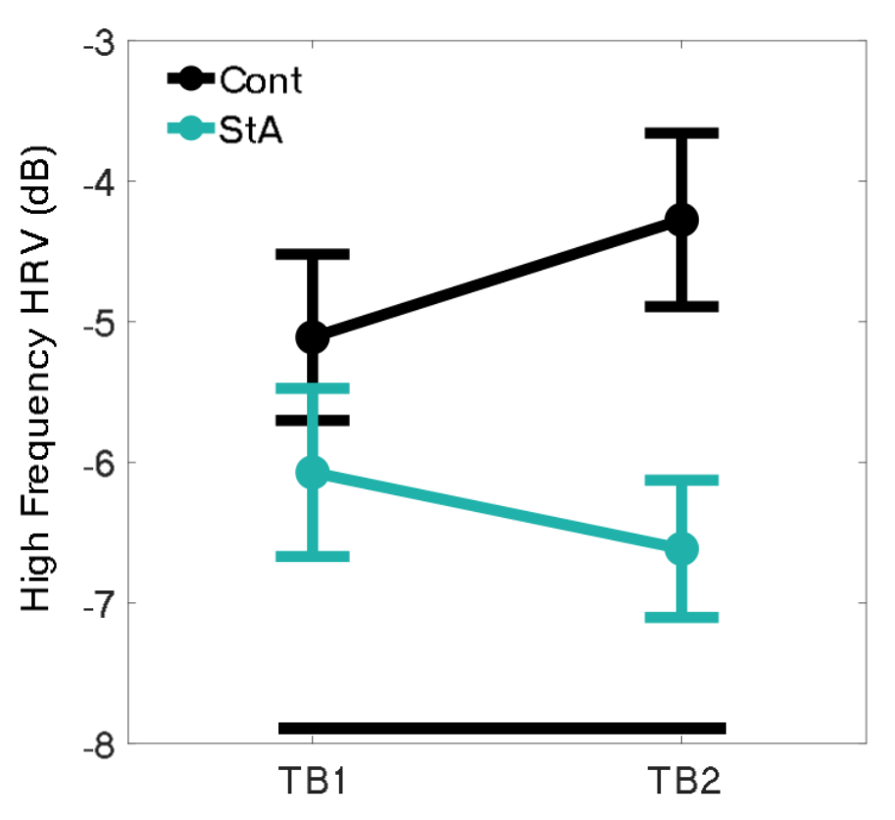

**Supplementary Figure 4. Spectral analysis of IBI time series data.** To complement our HRV proxy of state anxiety, an analysis of the frequency content of IBI data was performed to link our finding of reduced HRV to evidence of autonomic inflexibility (parasympathetic vagal modulation) in anxiety. The results showed reduced high frequency (0.15 – 0.4 Hz) content in the StA (mean -6.3, SEM 0.6) compared to Cont group (mean -4.7, SEM 0.5, *P* = 0.02). Also, a trend level interaction (*P* = 0.06) was found, but no Block effect (*P* = 0.08).

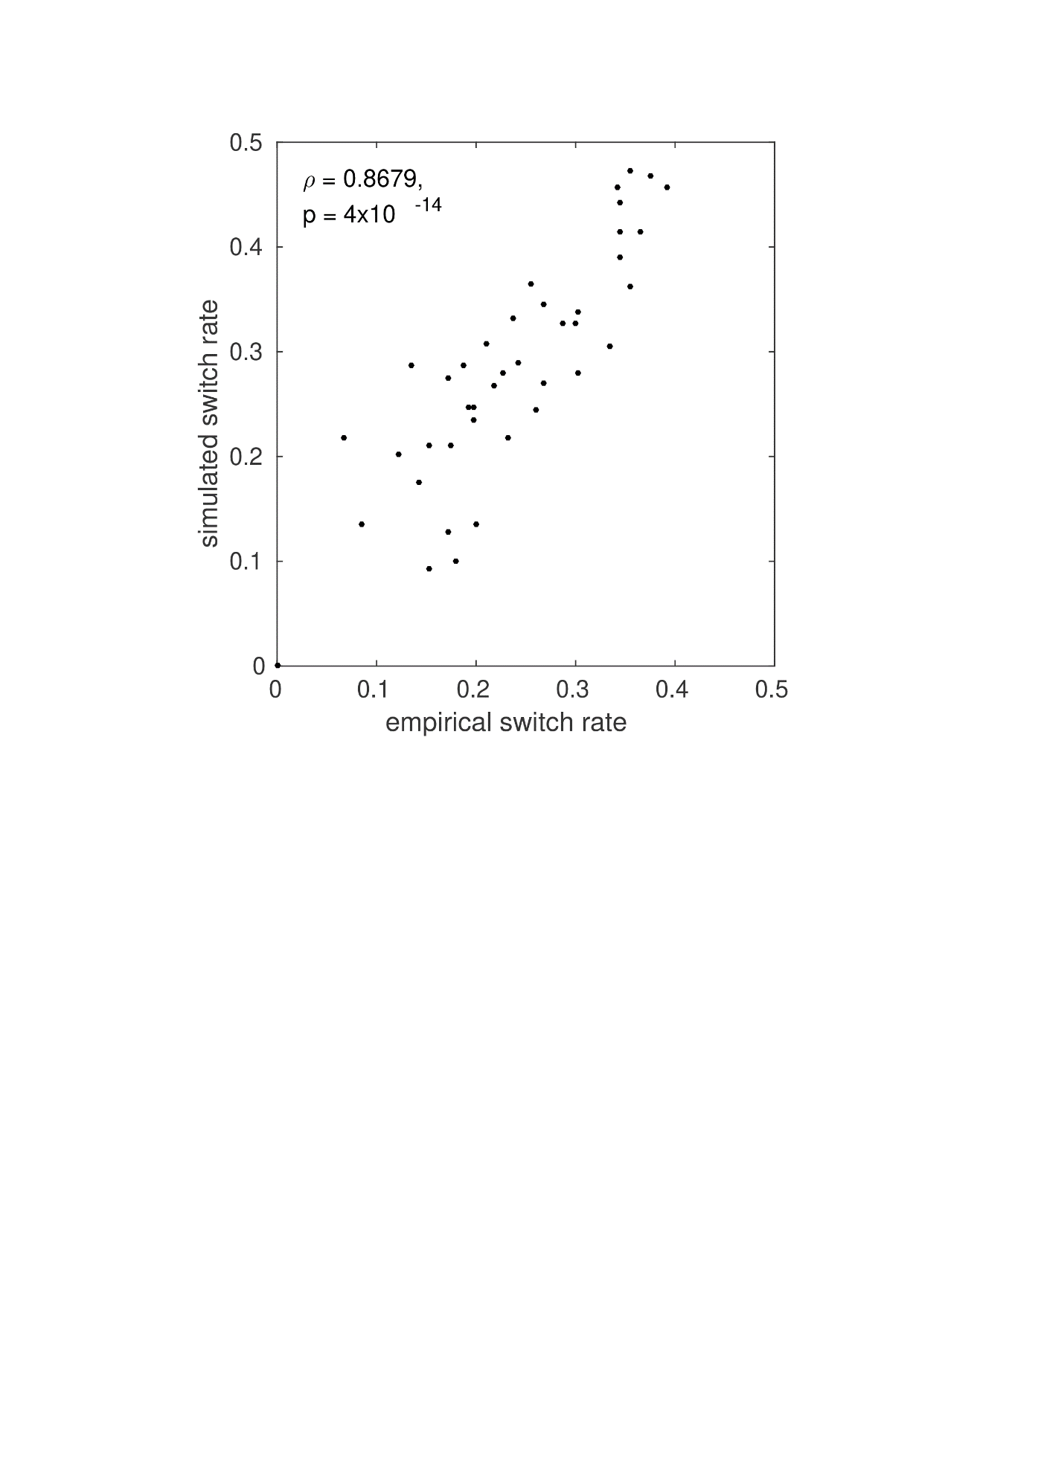

**Supplementary Figure** **5. Model check**. Simulated responses were generated using the estimated model parameters for each individual (ω2, ω3, ζ). We compared the probability of trial-to-trial response switch (Orange, Blue) between simulated and empirical data across participants computing the non-parametric Spearman rank correlation. There was a very high and significant rank correlation between both variables (N = 42): ρ = 0.8679, P = 4 x 10-14. Inspection of this association within each participant group revealed similar values (N = 21 in each case): ρCont = 0.8263, PCont = 4 x 10-6; ρStA = 0.8355, PStA = 2.5 x 10-6.

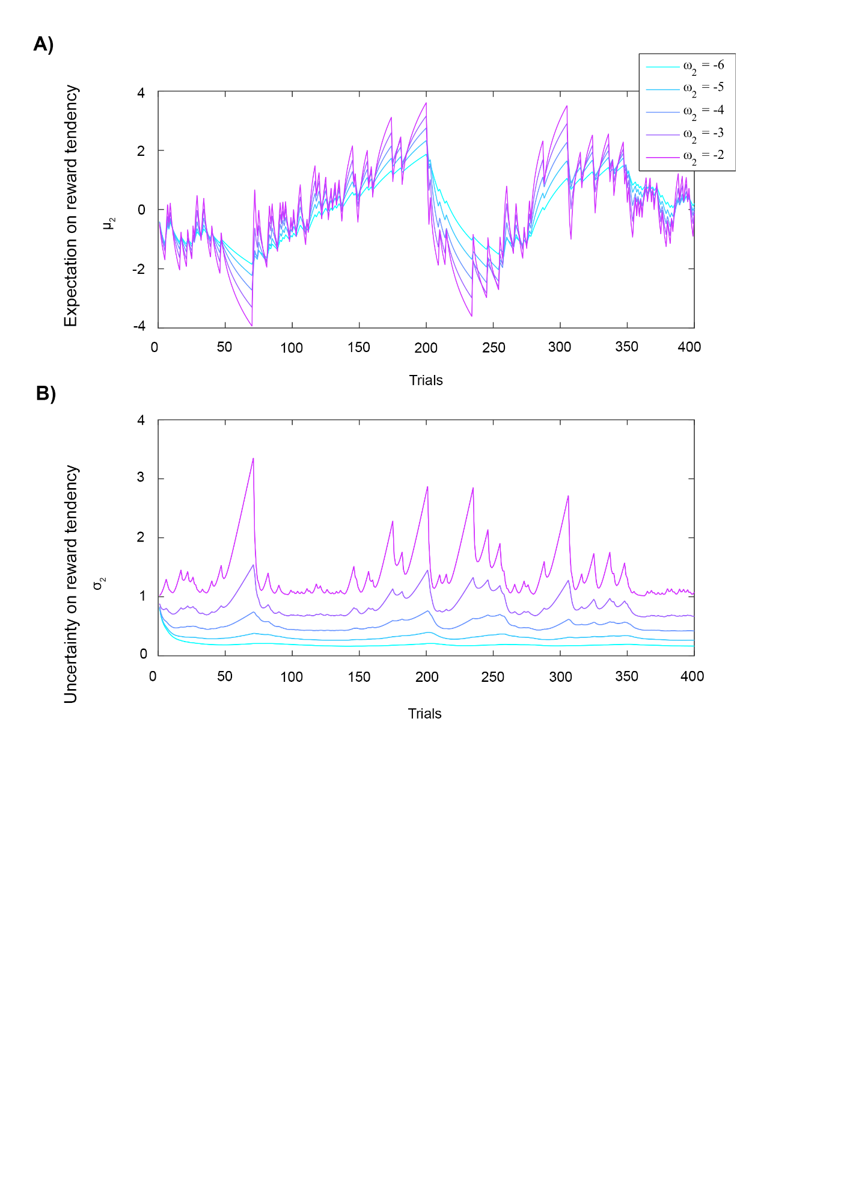

**Supplementary Figure 6. Simulated belief trajectories for μ2 and σ2.** Trajectories were simulated using the input data from participant 1 using the priors μ2(0) = 0, σ2(0) = 0.1, μ3(0) = 1, σ3(0) = 1, κ = 1, ω3 = -7, but modulating ω2. This parameter represents the tonic part of the variance in the Gaussian random walk for x2 and modulates the learning rate about stimulus outcomes at the lowest level. Here we show that **A)** decreasing ω2 is linked to smaller update steps on the reward tendency μ2, while **B)** decreasing ω2 also reduces the estimation uncertainty about the reward tendency, σ2.

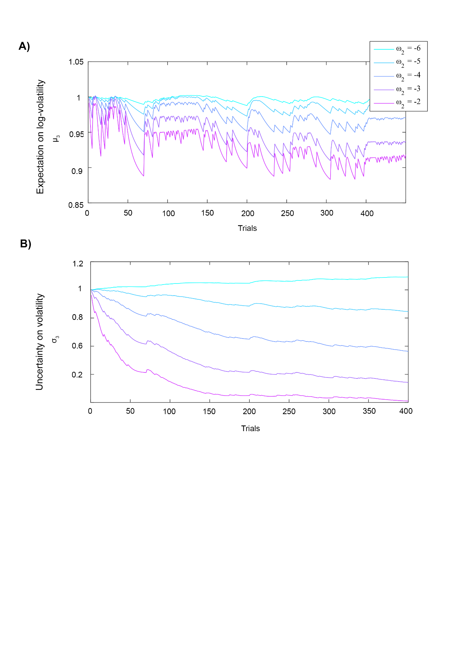

**Supplementary Figure 7. Simulated belief trajectories for μ3 and σ3.** Trajectories were simulated using the input data from participant 1 using the priors μ2(0) = 0, σ2(0) = 0.1, μ3(0) = 1, σ3(0) = 1, κ = 1, ω3 = -7, but modulating ω2. Here we show that decreasing ω2 leads to **A)** smaller update steps for the expectation of log-volatility μ3 and **B)** higher uncertainty σ3 about volatility. As we presented in our results, StA individuals had significantly lower ω2. This can explain why StA exhibited higher uncertainty about volatility σ3 when compared to Cont. The StA group did moreover, exhibit generally a higher (less reduced) expectation of volatility μ3, despite this effect being non-significant.

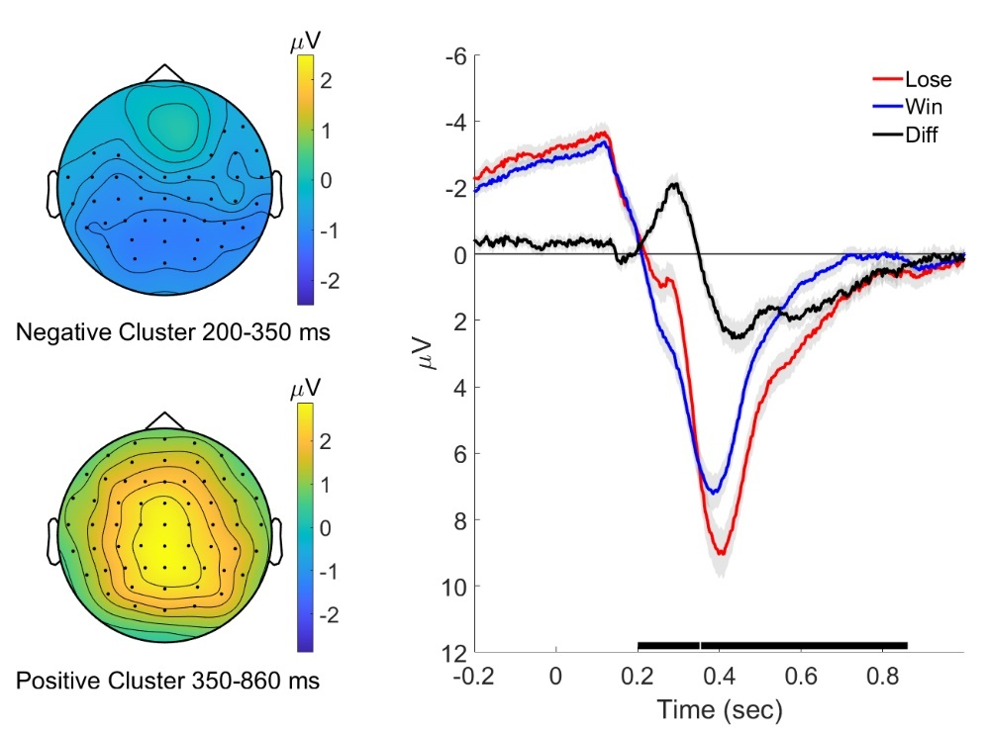

**Supplementary** **Figure 8**. **Results of the ERP response comparison for the main effect of outcome: wins and losses. Left panels**. Cluster-based random permutation analysis of ERP responses was carried out in the total population (N= 42) to assess the effect of the outcome (win, lose). Maps given for each cluster show the scalp topography of the significant cluster ERP differences between outcomes (win, lose). Black dots on the topographical maps indicate electrodes pertaining to a significant cluster (*P* < 0.025, two-tailed test). **Right panel**. Grand-mean ERP waveforms of the two outcomes (lose, red; win, blue) and the difference (lose minus win, black) are presented from all electrodes between -0.2 and 1 seconds, with SEM given as grey shaded areas. Significant clusters are denoted by black bars on the x-axis.

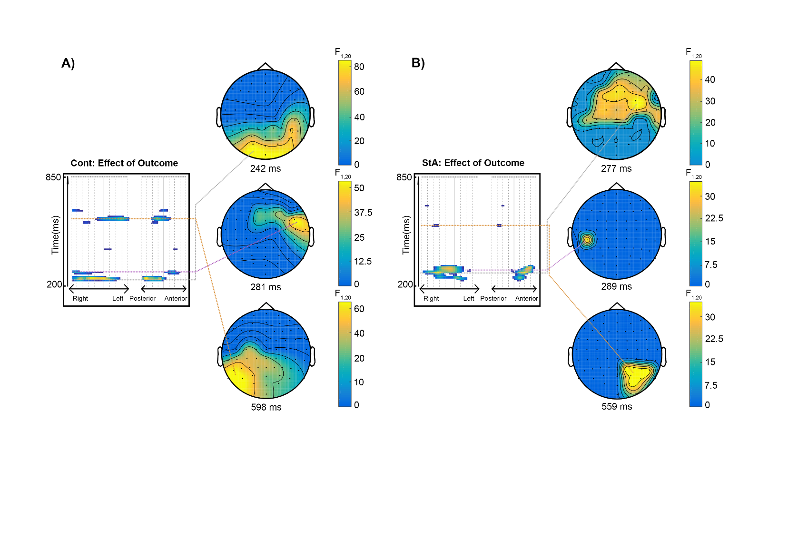

**Supplementary Figure 9.** **Signatures of the representation of trial outcomes on trial-wise ERPs. A)** Effect of trial outcomes in controls (Cont) correlated with EEG response changes across parietal-occipital and central-parietal electrodes between 229 ms to 257 ms, as shown in the topographical representation at the time of the maximum peak of the cluster (242 ms post stimulus, *PFWE* < 0.0001, with a cluster-defining threshold of *P* < 0.001). A smaller cluster was also found as shown in the middle topographical representation at 281 ms, with activation between267-287 ms (*PFWE* = 0.002) at right frontal and temporal electrodes. A later cluster was also shown between 583 ms to 618 ms with a peak at 598 ms over left parietal and central electrodes (P*FWE* < 0.0001). **B)** Effect of trial outcomes on EEG activity during state anxiety. In the state anxiety group (StA), trial outcomes were associated primarily with trial-wise ERP changes in right frontocentral electrodes. This effect, ranging from 228 ms and 316 ms, is shown in a topographic scalp map at the time of the maximum peak of the cluster (277 ms post stimulus, *PFWE* = <0.0001, with a cluster-defining threshold of *P* < 0.001). A second later cluster peaking at 371ms had a left parietal distribution. An additional smaller significant cluster was found between 286-297 ms in right parietal electrodes peaking at 289 ms (P*FWE* = 0.04), and later between 558-569 ms peaking at 559 ms (P*FWE* = 0.036).